1. INTRODUCTION:
Academic plagiarism has been defined as “the use of ideas, concepts, words, or structures without appropriately acknowledging the source to benefit in a setting where originality is expected". Forms of academic plagiarism vary in their degree of obfuscation ranging from unaltered copies (copy&paste), to slightly altered forms of plagiarism, such as interweaving text passages from multiple sources (shake&paste), to disguised forms of plagiarism, including paraphrases, translations, and idea plagiarism, and even the plagiarism of academic data. The easily identifiable copy&paste-type plagiarism is more prevalent among students, while heavily modified plagiarism is more characteristic of researchers, who have strong incentives to avoid detection by skillfully disguising unoriginal content. Research on plagiarism detection (PD) has yielded mature systems employing text retrieval to find similar documents. These systems reliably retrieve documents containing copied text, but often fail to identify disguised forms of academic plagiarism. As we briefly explain in Section 2, several approaches have been introduced to complement text-matching methods and to improve the detection capabilities for disguised forms of plagiarism. Compared to the many sophisticated text-based retrieval approaches that have been proposed for PD, analyzing images to detect academic plagiarism has attracted little research. In this paper, we examine the use of image similarity detection techniques as a promising method for plagiarism detection when textual similarity is lacking. For our use case, we define ‘images’ as the visual representations of data, e.g., in the form of bar charts, scatter plots, graphs, etc., as well as of concepts in the form of figures showing the schematic representations of entities and their relations, e.g., flow charts, organigrams, and component diagrams. Our definition also includes photographs and photo-realistic renderings. Images enable conveying much information in a compressed format, and they represent this information differently from the information conveyed in text. These characteristics make images a promising feature to examine when assessing the semantic similarity present in academic documents. Identifying semantic similarity is crucial for detecting translated plagiarism and idea plagiarism. In some cases, even the plagiarism of data becomes detectable if the data values can be reconstructed from graphs. The paper is structured as follows. In Section 2, we briefly present general PD approaches and previous work on image-based PD. We then begin Section 3 by informing our image-based PD approach through an investigation of image similarities found in documents that have been accused of constituting academic plagiarism. The remainder of Section 3 introduces the methods we developed and subsequently integrated into an adaptive and scalable image-based PD approach capable of targeting the identified types of image similarity.
1.1 Objective of the project:
Today, much more than in the past are discussed of plagiarism in the research. Conditions of the Web and Possibility of complex and smart searches in a short time, are rated to this, and as a result has arrived significant damages to the research. Tools designed to deal with plagiarism act on the text and ignore images. On the other, an inseparable part of information transfer is images that transfer the large volume of information in an article or scientific research. Because of the images include a very wide range and especially found large amounts of flowchart images in the computer's texts, and as respects, flowcharts are carrying a lot of information, could be one of the options of plagiarism. The purpose of this paper is examine the plagiarism rate of a paper in terms of flowchart images plagiarism using artificial neural network. The average of flowchart images recognition accuracy in terms of structure, nodes and edges in the proposed method with 81.91 percent, indicating the success of this method.
2. LITERATURE SERVUY:
Plagiarism Detection Approaches
Plagiarism detection is a specialized Information Retrieval (IR) task with the objective of comparing an input document to a large collection and retrieving all documents exhibiting similarities above a predefined threshold. PD systems typically follow a two-stage process consisting of candidate retrieval and detailed comparison. For candidate retrieval, the systems commonly employ efficient text retrieval methods, such as n-gram fingerprinting or vector space models. For the detailed comparison, the systems typically apply exhaustive string matching. However, such approaches are limited to finding near copies of a text. To detect disguised forms of academic plagiarism, researchers have proposed a variety of mono-lingual text analysis approaches employing semantic and syntactic features, as well as cross-lingual IR methods. Researchers also showed that hybrid approaches, i.e., the combined analysis of text and other content features, improve the retrieval effectiveness for PD tasks. Alzahrani et al. combined an analysis of text similarity and structural similarity. Gipp and Meuschke showed that the combined analysis of citation patterns and text similarity improves the identification of concealed academic plagiarism. Pertile et al. confirmed the positive effect of combining citation and text analysis and devised a hybrid approach using machine learning. Recently, Meuschke et al. demonstrated the benefit of analyzing the similarity of mathematical expressions and patterns of semantic concepts for improving the identification of academic plagiarism.
Image Analysis for Plagiarism Detection
Few studies have investigated the analysis of image similarity for PD. Hurtik and Hodakova use higher degree F-transform to provide a highly efficient and reliable method to identify exact copies of photographs or cropped parts there. However, the method does not consider image alterations aside from cropping. Iwanowski et al. evaluate the suitability of well-established feature point methods, such as SIFT, SURF, and BRISK, to retrieve exact and visually altered copies of photographs. Srivastava et al. address the same task using a combination of SIFT features extracted using SIFT and perceptual hashing. Feature point methods identify and match visually interesting areas of a scene. The methods are insensitive to affine image transformations, such as scaling or rotation, and relatively robust to changes in illumination or the introduction of noise. Perceptual hashing describes a set of methods that map perceived content of images, videos, or audio files to a hash value (pHash. Images perceived as similar by humans also result in similar pHash values, in contrast to cryptographic hashing, in which a minor change in the input results in a drastically different hash value. Thus, the similarity of images can be quantified as the similarity of their pHash values. If image components, such as shapes, are re-arranged, both feature point methods and perceptual hashing often fail. Iwanowski et al. mention that the effectiveness of the feature point approaches they tested decreases if the test images consist of multiple sub-images. We also observed this limitation in our tests. For example, the two compound images shown in Figure 10 in Appendix A consist of six and four sub-images, respectively. The image in the later document omits two of the sub-images present in the compound image from the source document. Applying the combination of SIFT feature extractor and MSAC feature estimator to compare these two compound images correctly identifies a high similarity between the two sub-images at the top in both compound images, but does not establish a similarity for the other sub-image pairs.
Comparing Images for Document Plagiarism Detection
The paper presents results of research oriented towards an application of image processing methods into document comparisons in view of their application into plagiarism-detection systems. Among all image processing methods, the feature-point ones, thanks to their invariance to various image transforms, are best suited for computing image similarity. In the paper various combination of feature point detectors and descriptors are investigated as potential tool for finding similar images in document. The methods are tested on the database consisting of scientific papers containing 5 well known image processing test images. Also, an idea is presented in the paper how the algorithms computing the image similarity may extend the functionality of plagiarism detection systems.
Reducing Computational Effort for Plagiarism Detection by using Citation Characteristics to Limit Retrieval Space
This paper proposes a hybrid approach to plagiarism detection in academic documents that integrates detection methods using citations, semantic argument structure, and semantic word similarity with character-based methods to achieve a higher detection performance for disguised plagiarism forms. Currently available software for plagiarism detection exclusively performs text string comparisons. These systems find copies, but fail to identify disguised plagiarism, such as paraphrases, translations, or idea plagiarism. Detection approaches that consider semantic similarity on word and sentence level exist and have consistently achieved higher detection accuracy for disguised plagiarism forms compared to character-based approaches. However, the high computational effort of these semantic approaches makes them infeasible for use in real-world plagiarism detection scenarios. The proposed hybrid approach uses citation-based methods as a preliminary heuristic to reduce the retrieval space with a relatively low loss in detection accuracy. This preliminary step can then be followed by a computationally more expensive semantic and character-based analysis. We show that such a hybrid approach allows semantic plagiarism detection to become feasible even on large collections for the first time.
Optical Character Recognition by Open source OCR Tool Tesseract: A Case Study.
Optical character recognition (OCR) method has been used in converting printed text into editable text. OCR is very useful and popular method in various applications. Accuracy of OCR can be dependent on text preprocessing and segmentation algorithms. Sometimes it is difficult to retrieve text from the image because of different size, style, orientation, complex background of image etc. We begin this paper with an introduction of Optical Character Recognition (OCR) method, History of Open Source OCR tool Tesseract, architecture of it and experiment result of OCR performed by Tesseract on different kinds images are discussed. We conclude this paper by comparative study of this tool with other commercial OCR tool Transym OCR by considering vehicle number plate as input. From vehicle number plate we tried to extract vehicle number by using Tesseract and Transym and compared these tools based on various parameters.
An Evaluation Framework for Plagiarism Detection
We present an evaluation framework for plagiarism detection. The framework provides performance measures that address the specifics of plagiarism detection, and the PAN-PC-10 corpus, which contains 64 558 artificial and 4 000 simulated plagiarism cases, the latter generated via Amazon's Mechanical Turk. We discuss the construction principles behind the measures and the corpus, and we compare the quality of our corpus to existing corpora. Our analysis gives empirical evidence that the construction of tailored training corpora for plagiarism detection can be automated, and hence be done on a large scale.
imPlag: Detecting image plagiarism using hierarchical near duplicate retrieval
Plagiarism in any form is a serious offense especially in academia and industry where integrity and royalty from work is of utmost importance. In this work, a novel hierarchical feature extraction as well as an approximate nearest neighbor search is proposed for detecting plagiarism of images. The proposed scheme is applicable for natural images as opposed to specific image classes reported in a previous work. A comprehensive experimental analysis is provided to illustrate the efficacy of the techniques chosen for the scheme. We demonstrate that the scheme shows a lot of promise for a wide variety of attacks and is amenable to scaling.
Comparing and combining Content- and Citation-based approaches for plagiarism detection
The vast amount of scientific publications available online makes it easier for students and researchers to reuse text from other authors and makes it harder for checking the originality of a given text. Reusing text without crediting the original authors is considered plagiarism. A number of studies have reported the prevalence of plagiarism in academia. As a consequence, numerous institutions and researchers are dedicated to devising systems to automate the process of checking for plagiarism. This work focuses on the problem of detecting text reuse in scientific papers. The contributions of this paper are twofold: (a) we survey the existing approaches for plagiarism detection based on content, based on content and structure, and based on citations and references; and (b) we compare content and citation-based approaches with the goal of evaluating whether they are complementary and if their combination can improve the quality of the detection. We carry out experiments with real data sets of scientific papers and concluded that a combination of the methods can be beneficial.
ImageNet Classification with Deep Convolutional Neural Networks
We trained a large, deep convolutional neural network to classify the 1.2 million high-resolution images in the ImageNet LSVRC-2010 contest into the 1000 different classes. On the test data, we achieved top-1 and top-5 error rates of 37.5% and 17.0% which is considerably better than the previous state-of-the-art. The neural network, which has 60 million parameters and 650,000 neurons, consists of five convolutional layers, some of which are followed by max-pooling layers, and three fully-connected layers with a final 1000-way softmax. To make training faster, we used non-saturating neurons and a very efficient GPU implementation of the convolution operation. To reduce overfitting in the fully-connected layers we employed a recently-developed regularization method called “dropout” that proved to be very effective. We also entered a variant of this model in the ILSVRC-2012 competition and achieved a winning top-5 test error rate of 15.3%, compared to 26.2% achieved by the second-best entry.
Understanding Plagiarism Linguistic Patterns, Textual Features, and Detection Methods

Plagiarism can be of many different natures, ranging from copying texts to adopting ideas, without giving credit to its originator. This paper presents a new taxonomy of plagiarism that highlights differences between literal plagiarism and intelligent plagiarism, from the plagiarist's behavioral point of view. The taxonomy supports deep understanding of different linguistic patterns in committing plagiarism, for example, changing texts into semantically equivalent but with different words and organization, shortening texts with concept generalization and specification, and adopting ideas and important contributions of others. Different textual features that characterize different plagiarism types are discussed. Systematic frameworks and methods of monolingual, extrinsic, intrinsic, and cross-lingual plagiarism detection are surveyed and correlated with plagiarism types, which are listed in the taxonomy. We conduct extensive study of state-of-the-art techniques for plagiarism detection, including character n-gram-based (CNG), vector-based (VEC), syntax-based (SYN), semantic-based (SEM), fuzzy-based (FUZZY), structural-based (STRUC), stylometric-based (STYLE), and cross-lingual techniques (CROSS). Our study corroborates that existing systems for plagiarism detection focus on copying text but fail to detect intelligent plagiarism when ideas are presented in different words.

3. SYSTEM ANALYSIS
3.1 Existing System
Today plagiarism due to the possibility of complex searches on the Web has arrived to research significant damages. Designed tools to deal with plagiarism act on the text and ignore images. On the other, images are inseparable part of information presentation that transfers the large volume of information in an article or scientific research, so that may be one of the plagiarism options.
Disadvantages of Existing System:
- Less Prediction.
- More time taking process.
3.2 Proposed System
The images contain a very wide range and especially in the computer literature to be found a lot flowchart images, the purpose of this paper is to examine the plagiarism of a paper in terms of used flowchart images plagiarism using Artificial Neural Networks. The proposed system was tested on 44 images of flowchart images public database that was used for CLEF-IP 2012 competitions. These images have been tested both CVC and INRIA methods. The recognition accuracy average of flowchart test images that have not been tampered in terms of structure, nodes and edges in the proposed method with 81.91 percent is indicating the high success of this method and increase of recognition in compared to both CVC and INRIA method.
Advantages of Proposed System:
- More Prediction.
- Less time taking process.
Modules:
- User Login
- Upload Source Files
- Upload Suspicious Files
- Upload Source Image
- Upload Suspicious Image
Modules Description:
User Login: user signup process completed and now clicks on ‘Login’ link user is login
Upload Source Files: Upload Source Files link to load all files from corpus folder and all files are loaded.
Upload Suspicious Files: Upload Suspicious File module to load suspicious file
Upload Source Image: Upload Source Images module to upload all images from ‘images’ folder and all database images histogram will be calculated and store in array and whenever we upload new test image then both histogram will get matched.
Upload Suspicious Image: Upload Suspicious Image link to upload some image selecting and uploading ‘112.jpg’ file and then click on ‘Open’ button we can see for database image and uploaded image we generated histogram and we can see there is no match in histogram so no plagiarism will be detected.
3.3. PROCESS MODEL USED WITH JUSTIFICATION
SDLC (Umbrella Model):
Umbrella Activity
Umbrella Activity
Umbrella Activity
- Feasibility Study
- TEAM FORMATION
- Project Specification PREPARATION

Business Requirement Documentation
ANALYSIS & DESIGN
CODE
UNIT TEST
DOCUMENT CONTROL

ASSESSMENT

TRAINING
INTEGRATION & SYSTEM TESTING

DELIVERY/INSTALLATION
ACCEPTANCE TEST
Requirements Gathering
SDLC is nothing but Software Development Life Cycle. It is a standard which is used by software industry to develop good software.
Stages in SDLC:
- Requirement Gathering
- Analysis
- Designing
- Coding
- Testing
- Maintenance
Requirements Gathering stage:
The requirements gathering process takes as its input the goals identified in the high-level requirements section of the project plan. Each goal will be refined into a set of one or more requirements. These requirements define the major functions of the intended application, define operational data areas and reference data areas, and define the initial data entities. Major functions include critical processes to be managed, as well as mission critical inputs, outputs and reports. A user class hierarchy is developed and associated with these major functions, data areas, and data entities. Each of these definitions is termed a Requirement. Requirements are identified by unique requirement identifiers and, at minimum, contain a requirement title and textual description.
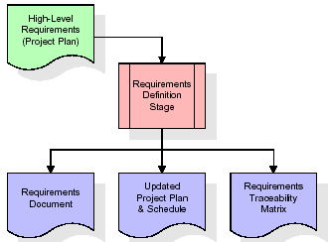
These requirements are fully described in the primary deliverables for this stage: the Requirements Document and the Requirements Traceability Matrix (RTM). The requirements document contains complete descriptions of each requirement, including diagrams and references to external documents as necessary. Note that detailed listings of database tables and fields are not included in the requirements document.
The title of each requirement is also placed into the first version of the RTM, along with the title of each goal from the project plan. The purpose of the RTM is to show that the product components developed during each stage of the software development lifecycle are formally connected to the components developed in prior stages.
In the requirements stage, the RTM consists of a list of high-level requirements, or goals, by title, with a listing of associated requirements for each goal, listed by requirement title. In this hierarchical listing, the RTM shows that each requirement developed during this stage is formally linked to a specific product goal. In this format, each requirement can be traced to a specific product goal, hence the term requirements traceability.
The outputs of the requirements definition stage include the requirements document, the RTM, and an updated project plan.
- Feasibility study is all about identification of problems in a project.
- No. of staff required to handle a project is represented as Team Formation, in this case only modules are individual tasks will be assigned to employees who are working for that project.
- Project Specifications are all about representing of various possible inputs submitting to the server and corresponding outputs along with reports maintained by administrator.
Analysis Stage:
The planning stage establishes a bird's eye view of the intended software product, and uses this to establish the basic project structure, evaluate feasibility and risks associated with the project, and describe appropriate management and technical approaches.
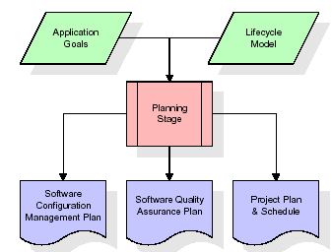
The most critical section of the project plan is a listing of high-level product requirements, also referred to as goals. All of the software product requirements to be developed during the requirements definition stage flow from one or more of these goals. The minimum information for each goal consists of a title and textual description, although additional information and references to external documents may be included. The outputs of the project planning stage are the configuration management plan, the quality assurance plan, and the project plan and schedule, with a detailed listing of scheduled activities for the upcoming Requirements stage, and high level estimates of effort for the out stages.
Designing Stage:
The design stage takes as its initial input the requirements identified in the approved requirements document. For each requirement, a set of one or more design elements will be produced as a result of interviews, workshops, and/or prototype efforts. Design elements describe the desired software features in detail, and generally include functional hierarchy diagrams, screen layout diagrams, tables of business rules, business process diagrams, pseudo code, and a complete entity-relationship diagram with a full data dictionary. These design elements are intended to describe the software in sufficient detail that skilled programmers may develop the software with minimal additional input.

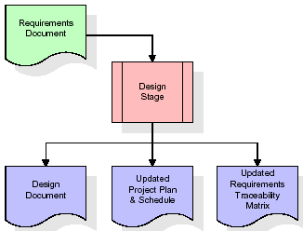
When the design document is finalized and accepted, the RTM is updated to show that each design element is formally associated with a specific requirement. The outputs of the design stage are the design document, an updated RTM, and an updated project plan.
Development (Coding) Stage:
The development stage takes as its primary input the design elements described in the approved design document. For each design element, a set of one or more software artifacts will be produced. Software artifacts include but are not limited to menus, dialogs, and data management forms, data reporting formats, and specialized procedures and functions. Appropriate test cases will be developed for each set of functionally related software artifacts, and an online help system will be developed to guide users in their interactions with the software.
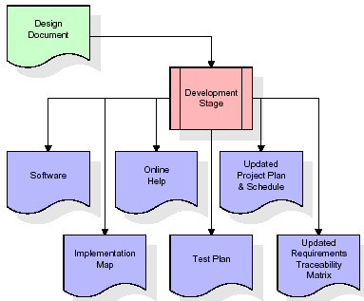

The RTM will be updated to show that each developed artifact is linked to a specific design element, and that each developed artifact has one or more corresponding test case items. At this point, the RTM is in its final configuration. The outputs of the development stage include a fully functional set of software that satisfies the requirements and design elements previously documented, an online help system that describes the operation of the software, an implementation map that identifies the primary code entry points for all major system functions, a test plan that describes the test cases to be used to validate the correctness and completeness of the software, an updated RTM, and an updated project plan.
Integration & Test Stage:
During the integration and test stage, the software artifacts, online help, and test data are migrated from the development environment to a separate test environment. At this point, all test cases are run to verify the correctness and completeness of the software. Successful execution of the test suite confirms a robust and complete migration capability. During this stage, reference data is finalized for production use and production users are identified and linked to their appropriate roles. The final reference data (or links to reference data source files) and production user list are compiled into the Production Initiation Plan.
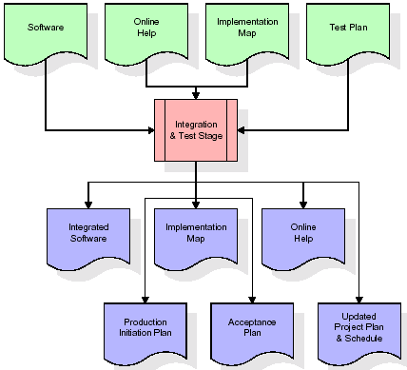
The outputs of the integration and test stage include an integrated set of software, an online help system, an implementation map, a production initiation plan that describes reference data and production users, an acceptance plan which contains the final suite of test cases, and an updated project plan.
- Installation & Acceptance Test:
During the installation and acceptance stage, the software artifacts, online help, and initial production data are loaded onto the production server. At this point, all test cases are run to verify the correctness and completeness of the software. Successful execution of the test suite is a prerequisite to acceptance of the software by the customer.
After customer personnel have verified that the initial production data load is correct and the test suite has been executed with satisfactory results, the customer formally accepts the delivery of the software.
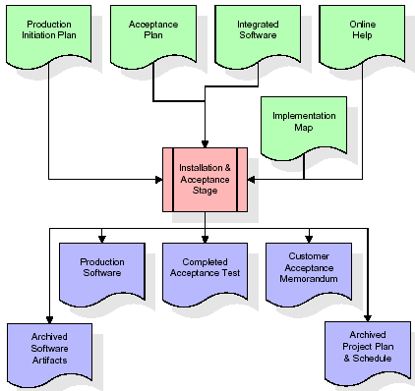
The primary outputs of the installation and acceptance stage include a production application, a completed acceptance test suite, and a memorandum of customer acceptance of the software. Finally, the PDR enters the last of the actual labor data into the project schedule and locks the project as a permanent project record. At this point the PDR "locks" the project by archiving all software items, the implementation map, the source code, and the documentation for future reference.
Maintenance:
Outer rectangle represents maintenance of a project, Maintenance team will start with requirement study, understanding of documentation later employees will be assigned work and they will undergo training on that particular assigned category. For this life cycle there is no end, it will be continued so on like an umbrella (no ending point to umbrella sticks).
3.4. Software Requirement Specification
3.4.1. Overall Description
A Software Requirements Specification (SRS) – a requirements specification for a software system is a complete description of the behavior of a system to be developed. It includes a set of use cases that describe all the interactions the users will have with the software. In addition to use cases, the SRS also contains non-functional requirements. Nonfunctional requirements are requirements which impose constraints on the design or implementation (such as performance engineering requirements, quality standards, or design constraints).
System requirements specification: A structured collection of information that embodies the requirements of a system. A business analyst, sometimes titled system analyst, is responsible for analyzing the business needs of their clients and stakeholders to help identify business problems and propose solutions. Within the systems development lifecycle domain, the BA typically performs a liaison function between the business side of an enterprise and the information technology department or external service providers. Projects are subject to three sorts of requirements:
- Business requirements describe in business terms what must be delivered or accomplished to provide value.
- Product requirements describe properties of a system or product (which could be one of several ways to accomplish a set of business requirements.)
- Process requirements describe activities performed by the developing organization. For instance, process requirements could specify .Preliminary investigation examine project feasibility, the likelihood the system will be useful to the organization. The main objective of the feasibility study is to test the Technical, Operational and Economical feasibility for adding new modules and debugging old running system. All system is feasible if they are unlimited resources and infinite time. There are aspects in the feasibility study portion of the preliminary investigation:
- ECONOMIC FEASIBILITY
A system can be developed technically and that will be used if installed must still be a good investment for the organization. In the economical feasibility, the development cost in creating the system is evaluated against the ultimate benefit derived from the new systems. Financial benefits must equal or exceed the costs. The system is economically feasible. It does not require any addition hardware or software. Since the interface for this system is developed using the existing resources and technologies available at NIC, There is nominal expenditure and economical feasibility for certain.
- Operational Feasibility
Proposed projects are beneficial only if they can be turned out into information system. That will meet the organization’s operating requirements. Operational feasibility aspects of the project are to be taken as an important part of the project implementation. This system is targeted to be in accordance with the above-mentioned issues. Beforehand, the management issues and user requirements have been taken into consideration. So there is no question of resistance from the users that can undermine the possible application benefits. The well-planned design would ensure the optimal utilization of the computer resources and would help in the improvement of performance status.
- TECHNICAL FEASIBILITY
Earlier no system existed to cater to the needs of ‘Secure Infrastructure Implementation System’. The current system developed is technically feasible. It is a web based user interface for audit workflow at NIC-CSD. Thus it provides an easy access to .the users. The database’s purpose is to create, establish and maintain a workflow among various entities in order to facilitate all concerned users in their various capacities or roles. Permission to the users would be granted based on the roles specified. Therefore, it provides the technical guarantee of accuracy, reliability and security.
3.4.2. External Interface Requirements
User Interface
The user interface of this system is a user friendly python Graphical User Interface.
Hardware Interfaces
The interaction between the user and the console is achieved through python capabilities.
Software Interfaces
The required software is python.
Operating Environment
Windows XP.
HARDWARE REQUIREMENTS:

Processor - Pentium –IV
- Speed - 1.1 Ghz
- RAM - 256 MB(min)
- Hard Disk - 20 GB
- Key Board - Standard Windows Keyboard
- Mouse - Two or Three Button Mouse
- Monitor - SVGA
SOFTWARE REQUIREMENTS:
- Operating System - Windows7/8
- Programming Language - Python
4. SYSTEM DESIGN
UML Diagram:
Class Diagram:
The class diagram is the main building block of object oriented modeling. It is used both for general conceptual modeling of the systematic of the application, and for detailed modeling translating the models into programming code. Class diagrams can also be used for data modeling. The classes in a class diagram represent both the main objects, interactions in the application and the classes to be programmed. In the diagram, classes are represented with boxes which contain three parts:
- The upper part holds the name of the class
- The middle part contains the attributes of the class
- The bottom part gives the methods or operations the class can take or undertake
Class Diagram:
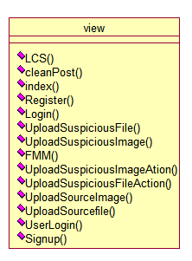
Use case Diagram:
A use case diagram at its simplest is a representation of a user's interaction with the system and depicting the specifications of a use case. A use case diagram can portray the different types of users of a system and the various ways that they interact with the system. This type of diagram is typically used in conjunction with the textual use case and will often be accompanied by other types of diagrams as well.
Use case Diagram:
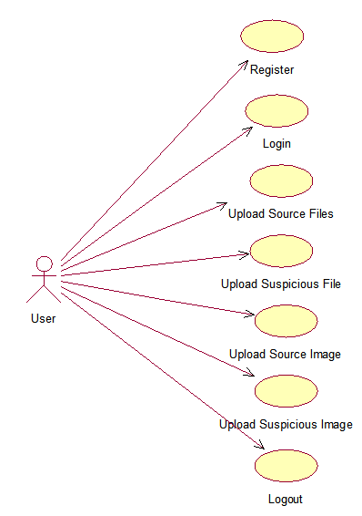

Sequence diagram:
A sequence diagram is a kind of interaction diagram that shows how processes operate with one another and in what order. It is a construct of a Message Sequence Chart. A sequence diagram shows object interactions arranged in time sequence. It depicts the objects and classes involved in the scenario and the sequence of messages exchanged between the objects needed to carry out the functionality of the scenario. Sequence diagrams are typically associated with use case realizations in the Logical View of the system under development. Sequence diagrams are sometimes called event diagrams, event scenarios, and timing diagrams.

Collaboration diagram:
A collaboration diagram describes interactions among objects in terms of sequenced messages. Collaboration diagrams represent a combination of information taken from class, sequence, and use case diagrams describing both the static structure and dynamic behavior of a system.

Component Diagram:
In the Unified Modeling Language, a component diagram depicts how components are wired together to form larger components and or software systems. They are used to illustrate the structure of arbitrarily complex systems.
Components are wired together by using an assembly connector to connect the required interface of one component with the provided interface of another component. This illustrates the service consumer - service provider relationship between the two components.
Component Diagram:
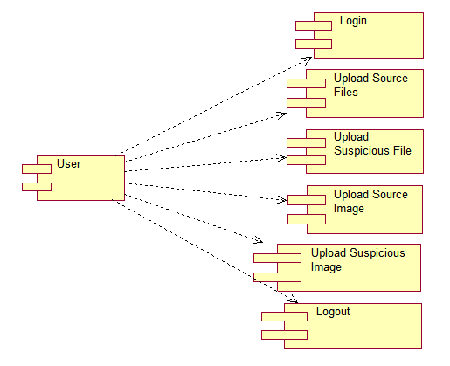

Deployment Diagram:
A deployment diagram in the Unified Modeling Language models the physical deployment of artifacts on nodes. To describe a web site, for example, a deployment diagram would show what hardware components ("nodes") exist (e.g., a web server, an application server, and a database server), what software components ("artifacts") run on each node (e.g., web application, database), and how the different pieces are connected (e.g. JDBC, REST, RMI).
The nodes appear as boxes, and the artifacts allocated to each node appear as rectangles within the boxes. Nodes may have sub nodes, which appear as nested boxes. A single node in a deployment diagram may conceptually represent multiple physical nodes, such as a cluster of database servers.
Deployment Diagram:
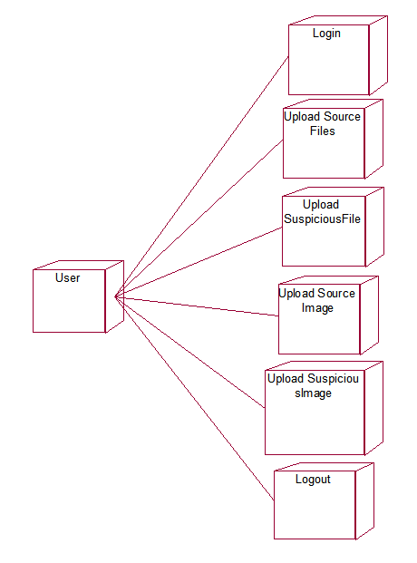

Activity Diagram:
Activity diagram is another important diagram in UML to describe dynamic aspects of the system. It is basically a flow chart to represent the flow form one activity to another activity. The activity can be described as an operation of the system. So the control flow is drawn from one operation to another. This flow can be sequential, branched or concurrent
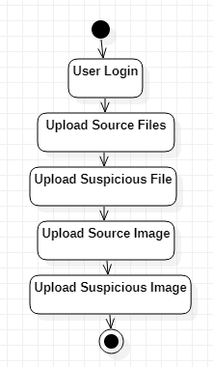

Data Flow Diagram:
Data flow diagrams illustrate how data is processed by a system in terms of inputs and outputs. Data flow diagrams can be used to provide a clear representation of any business function. The technique starts with an overall picture of the business and continues by analyzing each of the functional areas of interest. This analysis can be carried out in precisely the level of detail required. The technique exploits a method called top-down expansion to conduct the analysis in a targeted way.
As the name suggests, Data Flow Diagram (DFD) is an illustration that explicates the passage of information in a process. A DFD can be easily drawn using simple symbols. Additionally, complicated processes can be easily automated by creating DFDs using easy-to-use, free downloadable diagramming tools. A DFD is a model for constructing and analyzing information processes. DFD illustrates the flow of information in a process depending upon the inputs and outputs. A DFD can also be referred to as a Process Model. A DFD demonstrates business or technical process with the support of the outside data saved, plus the data flowing from the process to another and the end results.

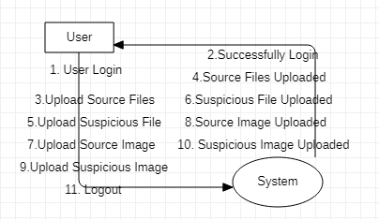
5. IMPLEMETATION
5.1 Python
Python is a general-purpose language. It has wide range of applications from Web development (like: Django and Bottle), scientific and mathematical computing (Orange, SymPy, NumPy) to desktop graphical user Interfaces (Pygame, Panda3D). The syntax of the language is clean and length of the code is relatively short. It's fun to work in Python because it allows you to think about the problem rather than focusing on the syntax.
History of Python:
Python is a fairly old language created by Guido Van Rossum. The design began in the late 1980s and was first released in February 1991.
Why Python was created?
In late 1980s, Guido Van Rossum was working on the Amoeba distributed operating system group. He wanted to use an interpreted language like ABC (ABC has simple easy-to-understand syntax) that could access the Amoeba system calls. So, he decided to create a language that was extensible. This led to design of a new language which was later named Python.
Why the name Python?
No. It wasn't named after a dangerous snake. Rossum was fan of a comedy series from late seventies. The name "Python" was adopted from the same series "Monty Python's Flying Circus".
Features of Python:
A simple language which is easier to learn
Python has a very simple and elegant syntax. It's much easier to read and write Python programs compared to other languages like: C++, Java, C#. Python makes programming fun and allows you to focus on the solution rather than syntax.
If you are a newbie, it's a great choice to start your journey with Python.
Free and open-source
You can freely use and distribute Python, even for commercial use. Not only can you use and distribute software’s written in it, you can even make changes to the Python's source code.
Python has a large community constantly improving it in each iteration.
Portability
You can move Python programs from one platform to another, and run it without any changes.
It runs seamlessly on almost all platforms including Windows, Mac OS X and Linux.
Extensible and Embeddable
Suppose an application requires high performance. You can easily combine pieces of C/C++ or other languages with Python code.
This will give your application high performance as well as scripting capabilities which other languages may not provide out of the box.
A high-level, interpreted language
Unlike C/C++, you don't have to worry about daunting tasks like memory management, garbage collection and so on.
Likewise, when you run Python code, it automatically converts your code to the language your computer understands. You don't need to worry about any lower-level operations.
Large standard libraries to solve common tasks
Python has a number of standard libraries which makes life of a programmer much easier since you don't have to write all the code yourself. For example: Need to connect MySQL database on a Web server? You can use MySQLdb library using import MySQLdb .
Standard libraries in Python are well tested and used by hundreds of people. So you can be sure that it won't break your application.
Object-oriented
Everything in Python is an object. Object oriented programming (OOP) helps you solve a complex problem intuitively.
With OOP, you are able to divide these complex problems into smaller sets by creating objects.
Applications of Python:
1. Simple Elegant Syntax
Programming in Python is fun. It's easier to understand and write Python code. Why? The syntax feels natural. Take this source code for an example:
a = 2
b = 3
sum = a + b
print(sum)
2. Not overly strict
You don't need to define the type of a variable in Python. Also, it's not necessary to add semicolon at the end of the statement.
Python enforces you to follow good practices (like proper indentation). These small things can make learning much easier for beginners.
3. Expressiveness of the language
Python allows you to write programs having greater functionality with fewer lines of code. Here's a link to the source code of Tic-tac-toe game with a graphical interface and a smart computer opponent in less than 500 lines of code. This is just an example. You will be amazed how much you can do with Python once you learn the basics.
4. Great Community and Support
Python has a large supporting community. There are numerous active forums online which can be handy if you are stuck.
5.2 Sample Code:
View.py
from django.shortcuts import render
from django.template import RequestContext
from django.contrib import messages
import pymysql
from django.http import HttpResponse
from django.conf import settings
from django.core.files.storage import FileSystemStorage
import matplotlib.pyplot as plt
import re
import cv2
import numpy as np
from string import punctuation
from nltk.corpus import stopwords
import nltk
from nltk.stem import WordNetLemmatizer
from nltk.stem import PorterStemmer
import os
from nltk.tokenize import word_tokenize

stop_words = set(stopwords.words('english'))
lemmatizer = WordNetLemmatizer()
porter = PorterStemmer()

def LCS(l1,l2): #LCS method
s1 = word_tokenize(l1)
s2 = word_tokenize(l2)
dp = [[None]*(len(s1)+1) for i in range(len(s2)+1)]
for i in range(len(s2)+1):
for j in range(len(s1)+1):
if i == 0 or j == 0:
dp[i][j] = 0
elif s2[i-1] == s1[j-1]:
dp[i][j] = dp[i-1][j-1]+1
else:
dp[i][j] = max(dp[i-1][j] , dp[i][j-1])
return dp[len(s2)][len(s1)]

def cleanPost(doc):
tokens = doc.split()
table = str.maketrans('', '', punctuation)
tokens = [w.translate(table) for w in tokens]
tokens = [word for word in tokens if word.isalpha()]
tokens = [w for w in tokens if not w in stop_words]
tokens = [word for word in tokens if len(word) > 1]
tokens = [lemmatizer.lemmatize(token) for token in tokens]
tokens = [porter.stem(token) for token in tokens]
tokens = ' '.join(tokens)
return tokens

text_files = []
text_data = []
image_files = []
image_data = []

def index(request):
if request.method == 'GET':
return render(request, 'index.html', {})

def Register(request):
if request.method == 'GET':
return render(request, 'Register.html', {})

def Login(request):
if request.method == 'GET':
return render(request, 'Login.html', {})

def UploadSuspiciousFile(request):
if request.method == 'GET':
return render(request, 'UploadSuspiciousFile.html', {})

def UploadSuspiciousImage(request):
if request.method == 'GET':
return render(request, 'UploadSuspiciousImage.html', {})

def FMM(name):#five modules algorithm
img = cv2.imread(name)
img = cv2.resize(img,(50,50))
img = cv2.cvtColor(img, cv2.COLOR_BGR2GRAY)
rows,cols = img.shape
for i in range(rows):
for j in range(cols):
if img[i,j] < 120:
img[i,j] = 210
for i in range(rows):
for j in range(cols):
k = img[i,j]
if (k % 5) == 4:
img[i,j] = k + 1
elif (k % 5) == 3:
img[i,j] = k + 2
elif (k % 5) == 2:
img[i,j] = k - 2
elif (k % 5) == 1:
img[i,j] = k - 1
for i in range(rows):
for j in range(cols):
k = img[i,j]
k = k / 5
img[i,j] = k
temp = img.ravel()
temp = np.min(img)
for i in range(rows):
for j in range(cols):
if img[i,j] > 0:
img[i,j] = img[i,j] - temp

hist = cv2.calcHist([img], [0], None, [256], [0, 256])
return hist

def UploadSuspiciousImageAction(request):
if request.method == 'POST' and request.FILES['t1']:
output = ''
myfile = request.FILES['t1']
fs = FileSystemStorage()
name = str(myfile)
filename = fs.save(name, myfile)
hist = FMM(name)
os.remove(name)
similarity = 0
file = 'No Match Found'
hist1 = 0
for i in range(len(image_files)):
metric_val = cv2.compareHist(hist, image_data[i], cv2.HISTCMP_INTERSECT)
if metric_val > similarity:
similarity = metric_val
file = image_files[i]
hist1 = image_data[i]
output = '<table border=1 align=center><tr><th>Source Original Image Name</th><th>Suspicious Image Name</th><th>Histogram Matching Score</th><th>Plagiarism Result</th></tr>'
result = 'No Plagiarism Detected'
print(str(name)+" "+str(similarity))
if similarity >= 39000:
result = 'Plagiarism Detected'
output+='<tr><td><font size="" color="white">'+file+'</td><td><font size="" color="white">'+name+'</td>'
output+='<td><font size="" color="white">'+str(similarity)+'</td><td><font size="" color="white">'+result+'</td></tr>'
context= {'data':output}
fig, ax = plt.subplots(2,1)
ax[0].plot(hist1, color = 'b')
ax[1].plot(hist, color = 'g')
plt.xlim([0, 256])
ax[0].set_title('Original image')
ax[1].set_title('Plagiarised image')
plt.show()
return render(request, 'SuspiciousImageResult.html', context)

def UploadSuspiciousFileAction(request):
if request.method == 'POST' and request.FILES['t1']:
output = ''
myfile = request.FILES['t1']
fs = FileSystemStorage()
name = str(myfile)
filename = fs.save("test.txt", myfile)
data = ''
with open("test.txt", "r", encoding='iso-8859-1') as file:
for line in file:
line = line.strip('\n')
line = line.strip()
data+=line+" "
file.close()
os.remove("test.txt")
data = cleanPost(data.strip().lower())
sim = 0
ff = 'No Match Found'
for i in range(len(text_data)):
similarity = LCS(text_data[i],data)
if similarity > sim:
sim = similarity
ff = text_files[i]

output = '<table border=1 align=center><tr><th>Source Original File Name</th><th>Suspicious File Name</th><th>LCS Score</th><th>Plagiarism Result</th></tr>'
result = 'No Plagiarism Detected'
similarity_percent = 0
if sim >= 0:
similarity_percent = sim/len(word_tokenize(data))
if similarity_percent >= 0.60:
result = 'Plagiarism Detected'
output+='<tr><td><font size="" color="white">'+ff+'</td><td><font size="" color="white">'+name+'</td>'
output+='<td><font size="" color="white">'+str(similarity_percent)+'</td><td><font size="" color="white">'+result+'</td></tr>'
context= {'data':output}
return render(request, 'SuspiciousFileResult.html', context)

def UploadSourceImage(request):
if request.method == 'GET':
if len(image_files) == 0:
for root, dirs, directory in os.walk('images'):
for j in range(len(directory)):
hist = FMM(root+"/"+directory[j])
image_data.append(hist)
image_files.append(directory[j])
output = '<table border=1 align=center><tr><th>Source Image File Name</th><th>Histogram Values</th></tr>'
for i in range(len(image_files)):
output+='<tr><td><font size="" color="white">'+image_files[i]+'</td><td><font size="" color="white">'+str(image_data[i])+"</td></tr>"
context= {'data':output}
return render(request, 'UploadSourceImage.html', context)

def UploadSource(request):
if request.method == 'GET':
if len(text_files) == 0:
for root, dirs, directory in os.walk('corpus-20090418'):
for j in range(len(directory)):
data = ''
with open(root+"/"+directory[j], "r", encoding='iso-8859-1') as file:
for line in file:
line = line.strip('\n')
line = line.strip()
data+=line+" "
file.close()
data = cleanPost(data.strip().lower())
text_files.append(directory[j])
text_data.append(data)
output = '<table border=1 align=center><tr><th>Source File Name</th><th>Words in File</th></tr>'
for i in range(len(text_files)):
length = len(text_data[i].split(" "))
output+='<tr><td><font size="" color="white">'+text_files[i]+'</td><td><font size="" color="white">'+str(length)+"</td></tr>"
context= {'data':output}
return render(request, 'UploadSource.html', context)

def UserLogin(request):
if request.method == 'POST':
username = request.POST.get('username', False)
password = request.POST.get('password', False)
index = 0
con = pymysql.connect(host='127.0.0.1',port = 3308,user = 'root', password = 'root', database = 'plagiarism',charset='utf8')
with con:
cur = con.cursor()
cur.execute("select * FROM users")
rows = cur.fetchall()
for row in rows:
if row[0] == username and password == row[1]:
index = 1
break
if index == 1:
file = open('session.txt','w')
file.write(username)
file.close()
context= {'data':'welcome '+username}
return render(request, 'UserScreen.html', context)
else:
context= {'data':'login failed'}
return render(request, 'Login.html', context)

def Signup(request):
if request.method == 'POST':
username = request.POST.get('username', False)
password = request.POST.get('password', False)
contact = request.POST.get('contact', False)
email = request.POST.get('email', False)
address = request.POST.get('address', False)
db_connection = pymysql.connect(host='127.0.0.1',port = 3308,user = 'root', password = 'root', database = 'plagiarism',charset='utf8')
db_cursor = db_connection.cursor()
student_sql_query = "INSERT INTO users(username,password,contact_no,email,address) VALUES('"+username+"','"+password+"','"+contact+"','"+email+"','"+address+"')"
db_cursor.execute(student_sql_query)
db_connection.commit()
print(db_cursor.rowcount, "Record Inserted")
if db_cursor.rowcount == 1:
context= {'data':'Signup Process Completed'}
return render(request, 'Register.html', context)
else:
context= {'data':'Error in signup process'}
return render(request, 'Register.html', context)
6. TESTING
Implementation and Testing:
Implementation is one of the most important tasks in project is the phase in which one has to be cautions because all the efforts undertaken during the project will be very interactive. Implementation is the most crucial stage in achieving successful system and giving the users confidence that the new system is workable and effective. Each program is tested individually at the time of development using the sample data and has verified that these programs link together in the way specified in the program specification. The computer system and its environment are tested to the satisfaction of the user.
Implementation
The implementation phase is less creative than system design. It is primarily concerned with user training, and file conversion. The system may be requiring extensive user training. The initial parameters of the system should be modifies as a result of a programming. A simple operating procedure is provided so that the user can understand the different functions clearly and quickly. The different reports can be obtained either on the inkjet or dot matrix printer, which is available at the disposal of the user. The proposed system is very easy to implement. In general implementation is used to mean the process of converting a new or revised system design into an operational one.

Testing
Testing is the process where the test data is prepared and is used for testing the modules individually and later the validation given for the fields. Then the system testing takes place which makes sure that all components of the system property functions as a unit. The test data should be chosen such that it passed through all possible condition. Actually testing is the state of implementation which aimed at ensuring that the system works accurately and efficiently before the actual operation commence. The following is the description of the testing strategies, which were carried out during the testing period.

System Testing
Testing has become an integral part of any system or project especially in the field of information technology. The importance of testing is a method of justifying, if one is ready to move further, be it to be check if one is capable to with stand the rigors of a particular situation cannot be underplayed and that is why testing before development is so critical. When the software is developed before it is given to user to use the software must be tested whether it is solving the purpose for which it is developed. This testing involves various types through which one can ensure the software is reliable. The program was tested logically and pattern of execution of the program for a set of data are repeated. Thus the code was exhaustively checked for all possible correct data and the outcomes were also checked.
Module Testing
To locate errors, each module is tested individually. This enables us to detect error and correct it without affecting any other modules. Whenever the program is not satisfying the required function, it must be corrected to get the required result. Thus all the modules are individually tested from bottom up starting with the smallest and lowest modules and proceeding to the next level. Each module in the system is tested separately. For example the job classification module is tested separately. This module is tested with different job and its approximate execution time and the result of the test is compared with the results that are prepared manually. The comparison shows that the results proposed system works efficiently than the existing system. Each module in the system is tested separately. In this system the resource classification and job scheduling modules are tested separately and their corresponding results are obtained which reduces the process waiting time.
Integration Testing
After the module testing, the integration testing is applied. When linking the modules there may be chance for errors to occur, these errors are corrected by using this testing. In this system all modules are connected and tested. The testing results are very correct. Thus the mapping of jobs with resources is done correctly by the system.
Acceptance Testing
When that user fined no major problems with its accuracy, the system passers through a final acceptance test. This test confirms that the system needs the original goals, objectives and requirements established during analysis without actual execution which elimination wastage of time and money acceptance tests on the shoulders of users and management, it is finally acceptable and ready for the operation.
Test Case Id | Test Case Name | Test Case Desc. | Test Steps |  |  | Test Case Status | Test Priority
 |  |  | Step | Expected | Actual
01 | Users Login | Verify either the Users are login or not | Without having the authenticate details | Users are cannot login to the system | Users can login to the system | High | High
02 | Upload Source Files | Verify either the source files are uploaded or not | Without uploading Source files | We cannot do further operations | We can do further operations | High | High
03 | Upload Suspicious Files | Verify either the suspicious files are uploaded or not | Without uploading suspicious files | We cannot do further operations | We can do further operations | High | High
04 | Upload Source image | Verify either the source image are uploaded or not | Without uploading Source image | We cannot do further operations | We can do further operations | High | High
05 | Upload Suspicious images | Verify either the suspicious images are uploaded or not | Without uploading Suspicious images | We cannot do further operations | We can do further operations | High | High
7. SCREENSHOTS
To run project install python 3.7 and then install DJANGO server and deploy code on that server and run from browser to get below screen

In above screen click on ‘New User Signup Here’ link to get below screen
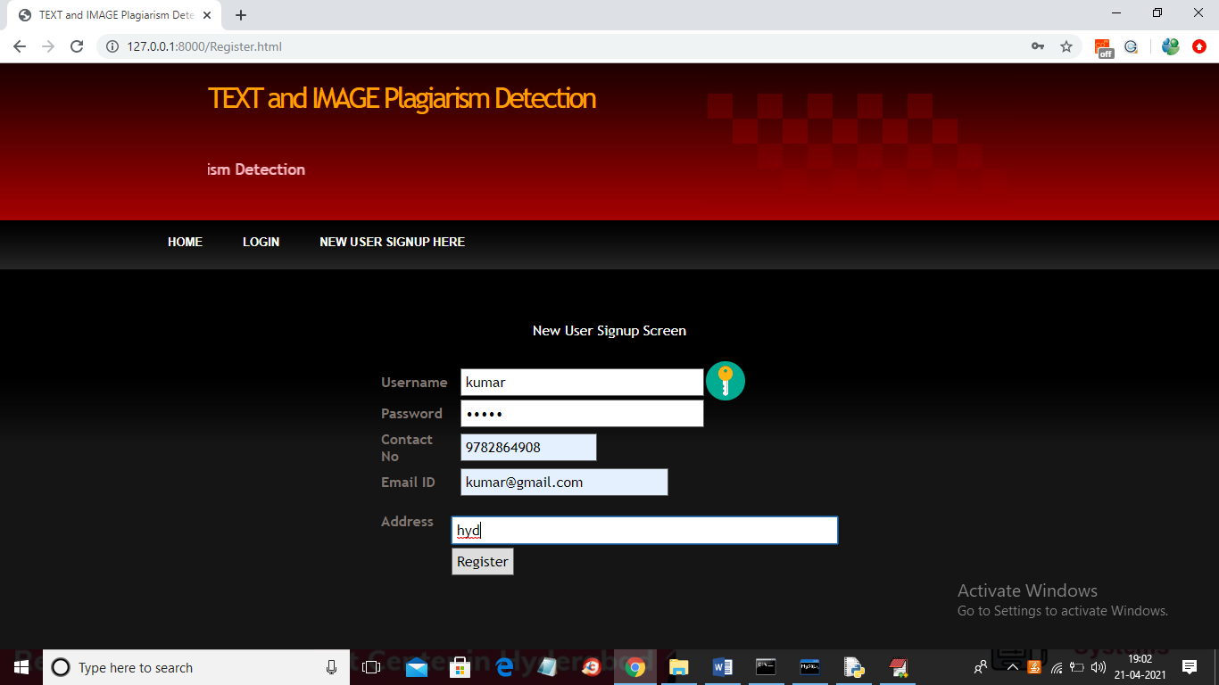
In above screen user signup details entered and then click on ‘Register’ button to get below screen
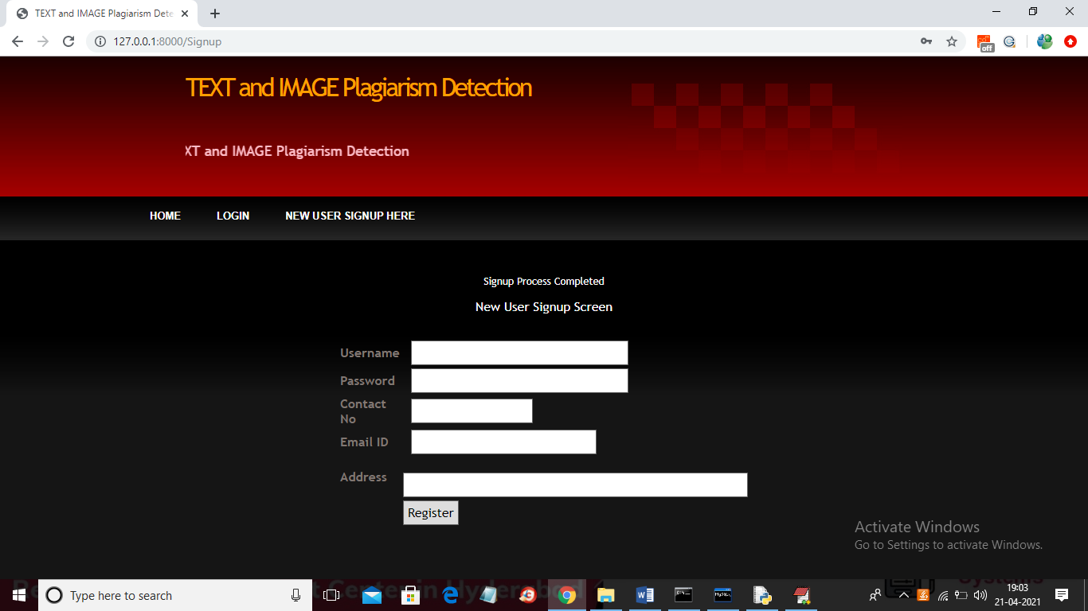
In above screen user signup process completed and now clicks on ‘Login’ link to get below screen
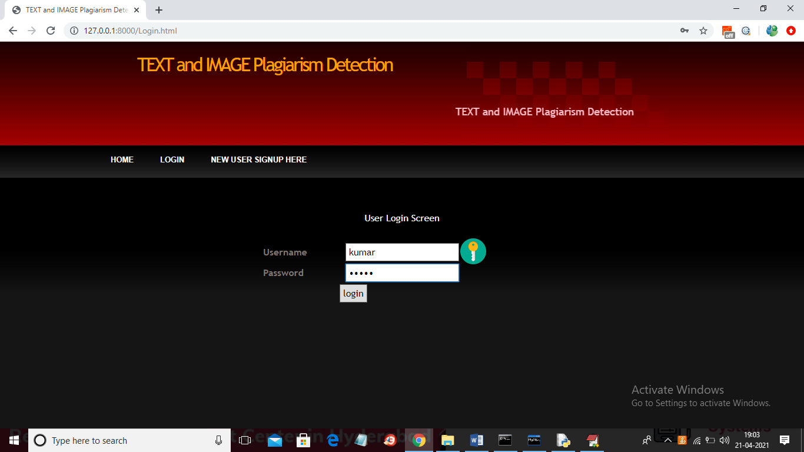
In above screen user is login and then click on button to get below screen

In above screen click on ‘Upload Source Files’ link to load all files from corpus folder
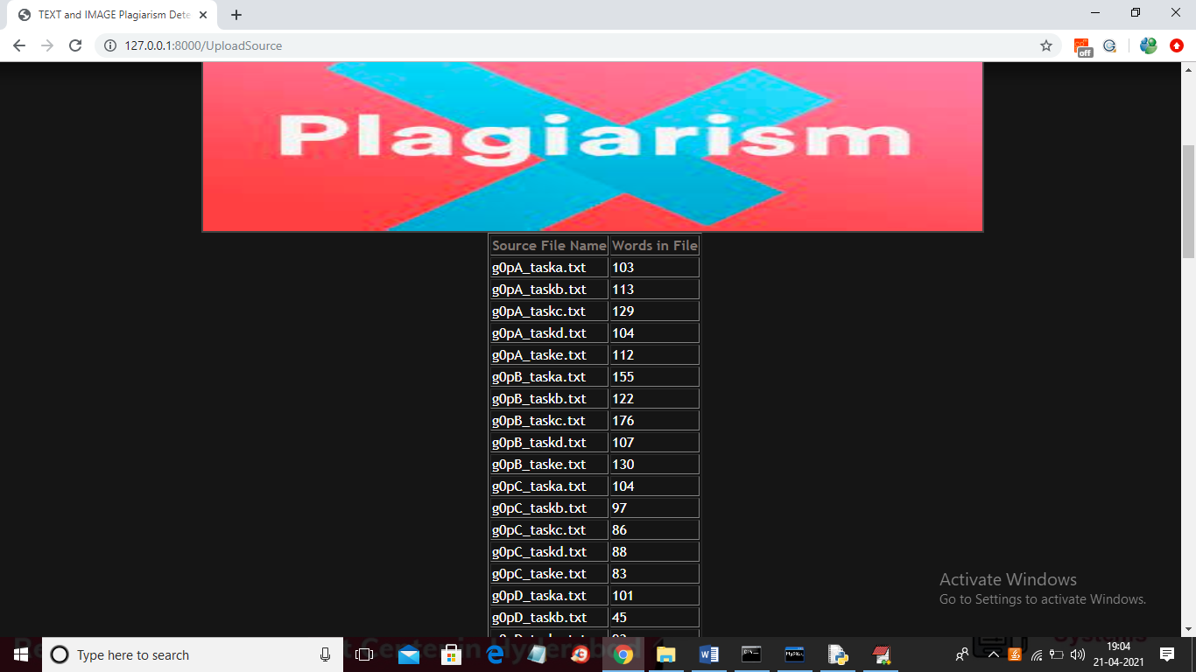
In above screen all files are loaded now click on ‘Upload Suspicious File’ button to load suspicious file and get result
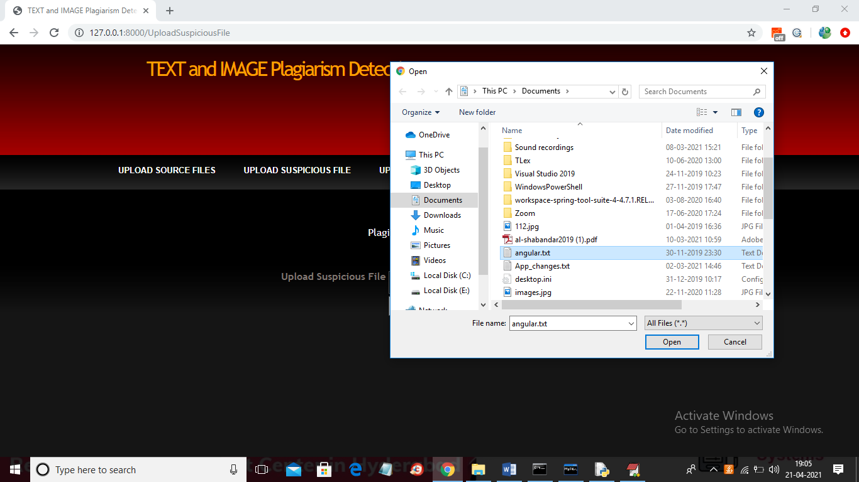
In above screen I am selecting and uploading ‘angular.txt’ file and then click on ‘Open’ button to get below result and then click on ‘Check Plagiarism’ button to get result

In above screen angular.txt file matched very little with g)pB_taskb.txt corpus file and we got similarity score as 0.03 so no plagiarism detected and now upload any file from corpus and see result
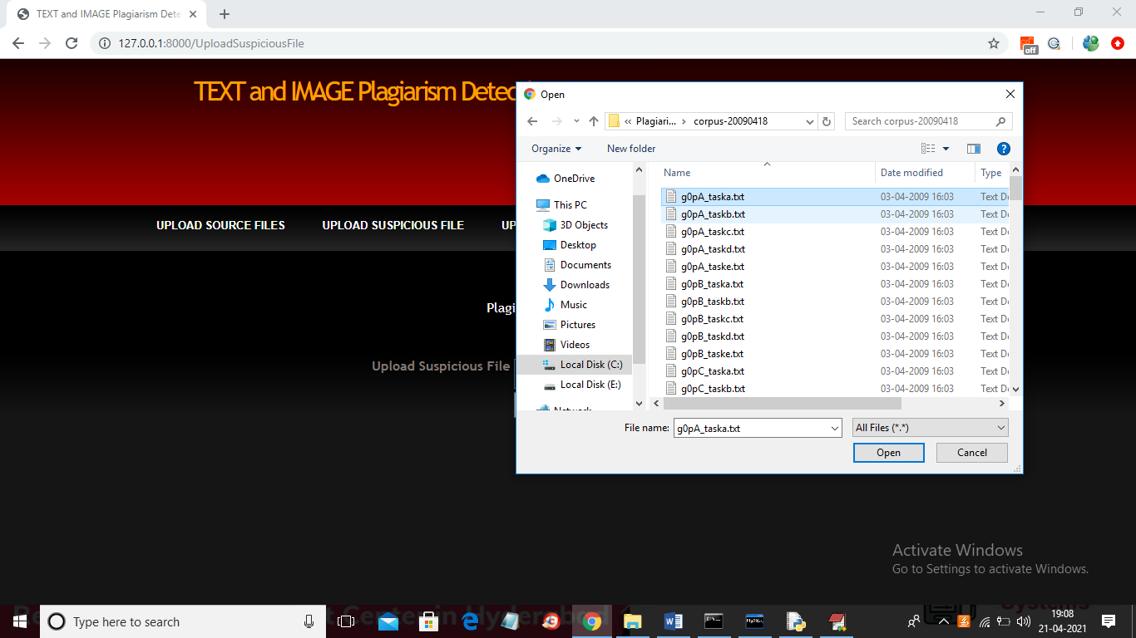
In above screen I am selecting and uploading first file and then click on button to get below result

In above screen LCS score is 1.0 which means 100% matched with corpus file so plagiarism detected and similarly not only this u may enter any text file and get result. Now click on ‘Upload Source Images’ link to upload all images from ‘images’ folder
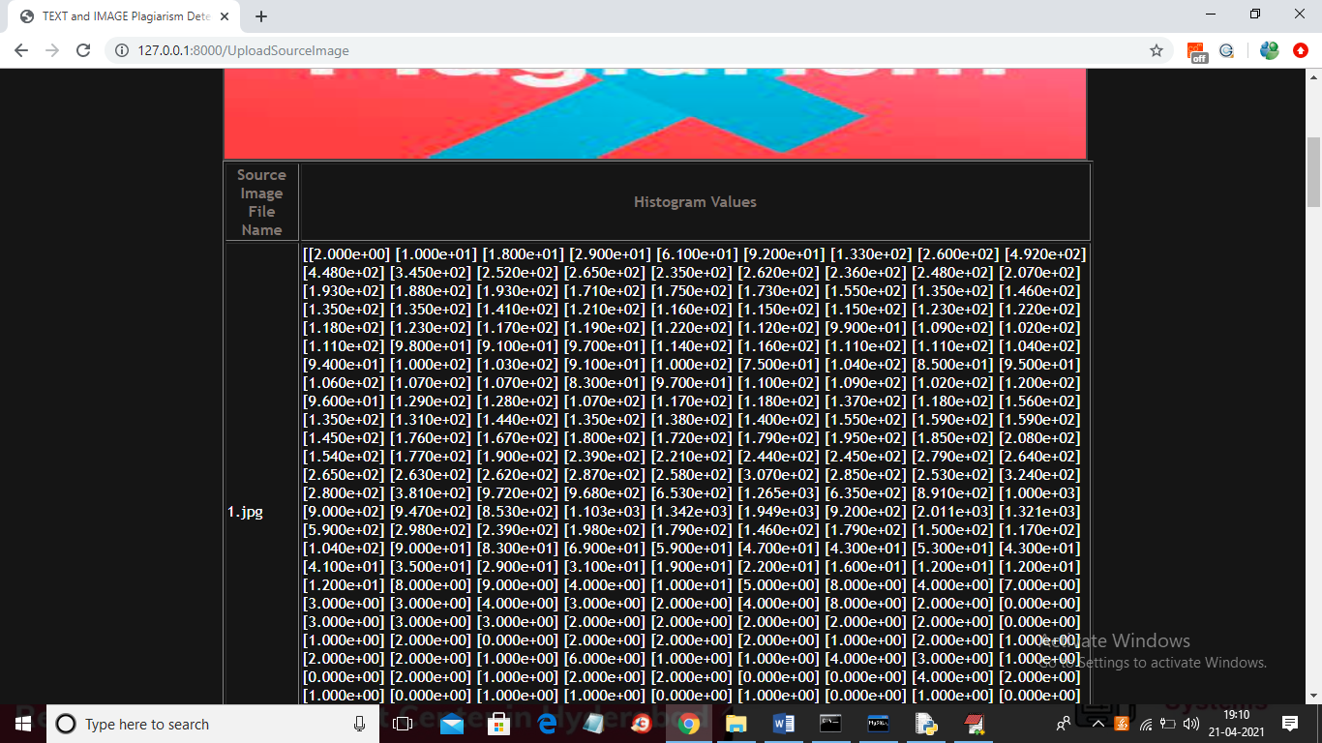
In above screen from all database images histogram will be calculated and store in array and whenever we upload new test image then both histogram will get matched and now click on ‘Upload Suspicious Image’ link to upload some image
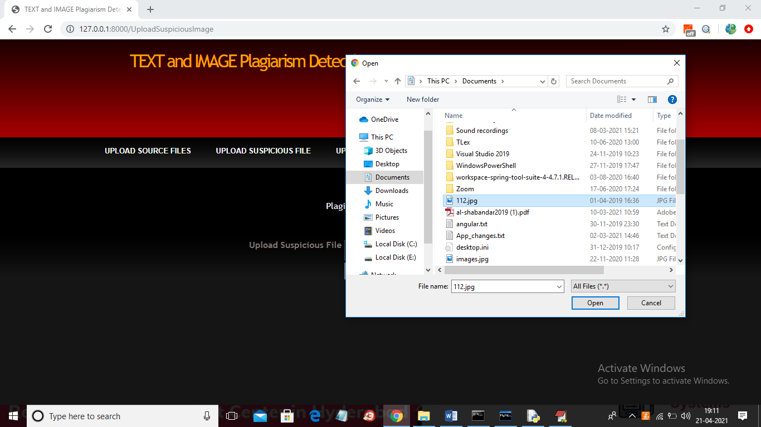
In above screen I am selecting and uploading ‘112.jpg’ file and then click on ‘Open’ button to get below result
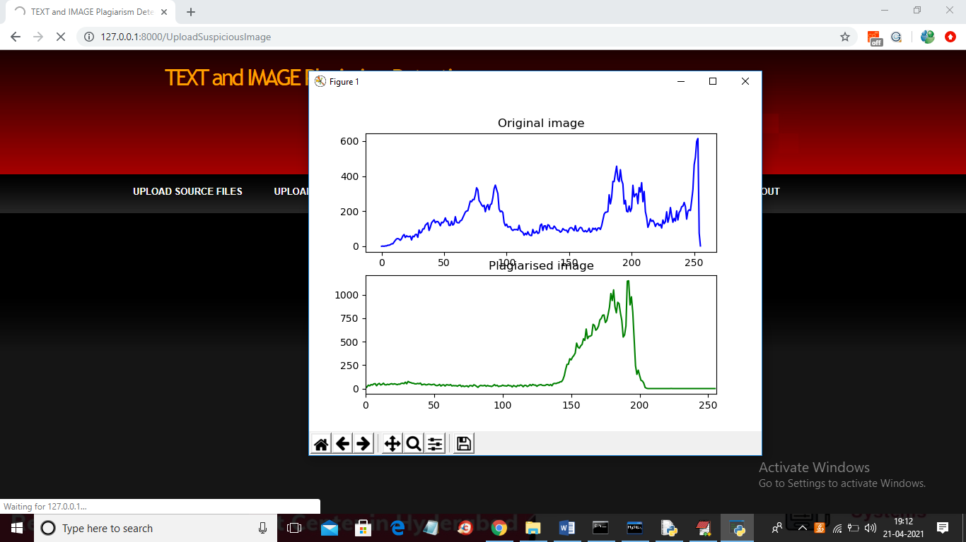
In above screen we can see for database image and uploaded image we generated histogram and we can see there is no match in histogram so no plagiarism will be detected and now close above graph to get below result

In above screen histogram pixel matching score is 15173 out of 40000 pixels so image is not plagiarized and now upload image from “images” folder and see result
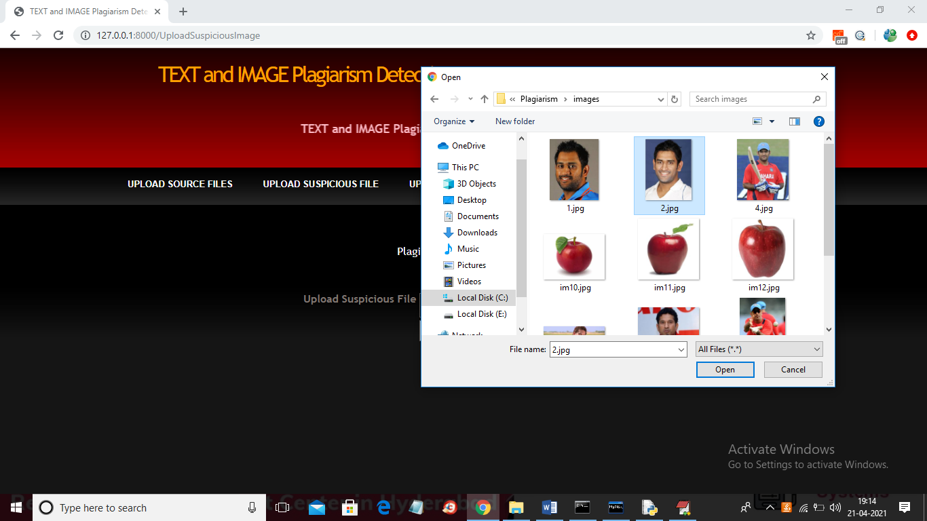
In above screen I am selecting and uploading ‘2.jpg’ file from “images” database folder and below is the result
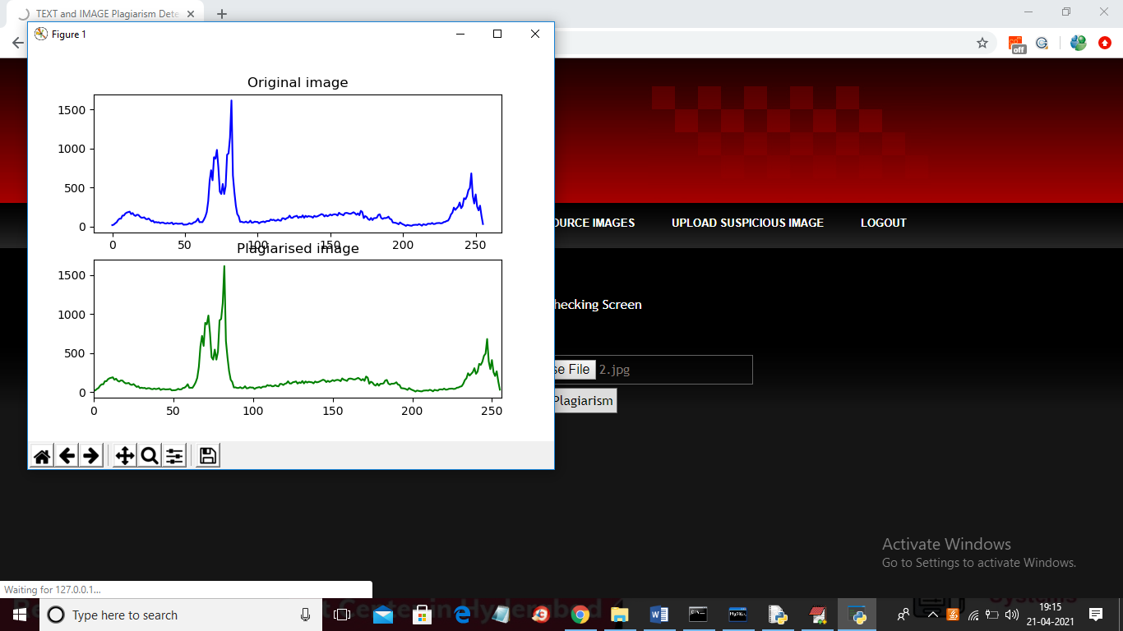
In above screen we can both original and uploaded image histogram is matching 100% so plagiarism is detected and now close above graph to get below result

In above screen histogram matching score is 40000 which means all pixels matched so plagiarism is detected in above result.
Similarly u can upload any text file and image and test the application
8. CONCLUSION

We introduced an image-based plagiarism detection approach that adapts itself to forms of image similarity found in academic work. The adaptivity of the approach is achieved by including methods that analyze heterogeneous image features, selectively employing analysis methods depending on their suitability for the input image, using a flexible procedure to determine suspicious image similarities, and enabling easy inclusion of additional analysis methods in the future. To derive requirements for our approach, we examined images contained in the VroniPlag collection. This real-world collection is the result of a crowd-sourced project documenting alleged and confirmed cases of academic plagiarism. From these cases, we introduced a classification of the image similarity types that we observed. We subsequently proposed our adaptive image-based PD approach. Our process integrates perceptual hashing, for which we extended the detection capabilities by including an extraction procedure for sub-images. Since textual labels are common in academic images, we devised and integrated two approaches using OCR to extract text from images and use the textual features for similarity assessments. To address the problem of data reuse, we integrated an analysis method capable of identifying equivalent bar charts. To quantify the suspiciousness of identified similarities, we presented an outlier detection process. The evaluation of our PD process demonstrates reliable performance and extends the detection capabilities of existing image-based detection approaches. We provide our code as open source and encourage other developers to extend and adapt our approach.
9. REFERENCES
[1] Salha Alzahrani, Vasile Palade, Naomie Salim, and Ajith Abraham. 2011. Using Structural Information and Citation Evidence to Detect Significant Plagiarism Cases in Scientific Publications. JASIST 63(2) (2011).
[2] Salha M. Alzahrani, Naomie Salim, and Ajith Abraham. 2012. Understanding Plagiarism Linguistic Patterns, Textual Features, and Detection Methods. In IEEE Trans. Syst., Man, Cybern. C, Appl. Rev., Vol. 42.
[3] Yaniv Bernstein and Justin Zobel. 2004. A Scalable System for Identifying Coderivative Documents. In Proc. SPIRE. LNCS, Vol. 3246. Springer.
[4] Teddi Fishman. 2009. “We know it when we see it"? is not good enough: toward a standard definition of plagiarism that transcends theft, fraud, and copyright. In Proc. Asia Pacific Conf. on Educational Integrity.
[5] Bela Gipp. 2014. Citation-based Plagiarism Detection - Detecting Disguised and Cross-language Plagiarism using Citation Pattern Analysis. Springer.
[6] Cristian Grozea and Marius Popescu. 2011. The Encoplot Similarity Measure for Automatic Detection of Plagiarism. In Proc. PAN WS at CLEF.
[7] Azhar Hadmi, William Puech, Brahim Ait Es Said, and Abdellah Ait Ouahman. 2012. Watermarking. Vol. 2. InTech, Chapter Perceptual Image Hashing.
[8] Petr Hurtik and Petra Hodakova. 2015. FTIP: A tool for an image plagiarism detection. In Proc. SoCPaR.
[9] Marcin Iwanowski, Arkadiusz Cacko, and Grzegorz Sarwas. 2016. Comparing Images for Document Plagiarism Detection. In Proc. ICCVG.
[10] Yangqing Jia, Evan Shelhamer, Jeff Donahue, Sergey Karayev, Jonathan Long, Ross Girshick, Sergio Guadarrama, and Trevor Darrell. 2014. Caffe: Convolutional Architecture for Fast Feature Embedding. In Proc. Multimedia.
[11] H.F. Judson. 2004. The Great Betrayal: Fraud in Science. Harcourt.
[12] Jan Kasprzak and Michal Brandejs. 2010. Improving the Reliability of the Plagiarism Detection System. In Proc. PAN WS at CLEF.
[13] Alex Krizhevsky, Ilya Sutskever, and Geoffrey E Hinton. 2012. ImageNet Classification with Deep Convolutional Neural Networks. In Proc. NIPS.
[14] Donald L. McCabe. 2005. Cheating among College and University Students: A North American Perspective. IJEI 1, 1 (2005).
[15] Norman Meuschke and Bela Gipp. 2013. State-of-the-art in detecting academic plagiarism. IJEI 9, 1 (2013).

